**What does it cost us to provide Member Care?**

**Here are some sample expenses**

|  |  |
| --- | --- |
| Go to Team Retreat in Madrid | $860 |
| Go to Team Retreat in Ukraine | $1,190 |
| Visit a team in Berlin | $500 |
| (we made 10 trips in 2017, together or separately) | |
| Phone & internet bill monthly | $60 |
| Monthly hospitality costs | $50 |
| Average travel costs per month | $320 |

**How can you help support the costs for Paul & Liz?**

**The following samples may give you some ideas**

|  |  |
| --- | --- |
| Cover our communication costs | $60 monthly |
| Cover average monthly travel costs | $320 monthly |
| Hospitality-says to missionaries “You’re special!” | $50 monthly |
| Send us to a team retreat | $800 - $1,200 |
| General support | $50-$100 month |

We can say with Paul, “through us your generosity will result in thanksgiving to God. (2 Cor 9:11b)”

Please contact us with any questions you have about our support.

For information about how to give go to <https://www.mtw.org/missionaries?query=Meiners>

The Meiners’ Account number 14728

Or us the tear off portion of our prayer card

The NEW Donation address for mailing donations is:

Mission to the World, P.O. Box 744165, Atlanta, GA 30374-4165

.

**Paul & Liz Meiners**

**Providing Member Care to MTW Missionaries in Europe**

**What kinds of care needs do missionaries express?**

“I’ve spent 3 years raising support and learning a language to join my team, but now I’m having trouble fitting into their life and ministry.”

“We’re making real progress adapting to our country and building relationships with national colleagues in the church. We’re concerned, however, that our teenage children are becoming too “at home” in the culture – the friends they have available and the beliefs of the culture around them are challenging to their relationship with the Lord.”

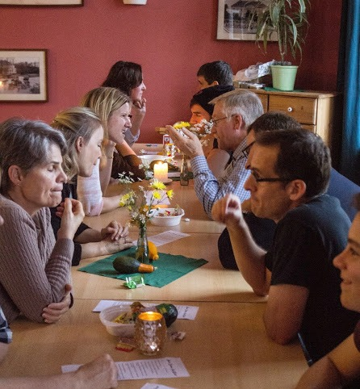 “The partnership with the national church is stretching me in ways I didn’t expect – their sense of history, leadership style, priorities and vision for the church are not what I was used to.”

“Ministry is a slog! It takes so much work, prayer and planning for limited results. It is hard to keep motivated.”

“I am spiritually challenged by the culture around me and don’t get enough feeding from the ministry we’re part of. Keeping up my own relationship with God is an ongoing challenge. I don’t feel qualified to be my own pastor!”

“I know God can and will use me here, but I have to keep remembering His promises, be faithful, and wait for his timing.”

**How do Paul & Liz care for our missionaries?**

**Listening** - Keeping in touch via Skype, email, phone

**Praying** consistently for them – God is their help!

**Answering** - Resourcing them with materials for their growth and facing their issues

**Showing Up** - at team retreats, and their place of ministry.

**Supporting** team leaders, “Member Care Friends”, and Pastoral Associate Couples in their care for them.

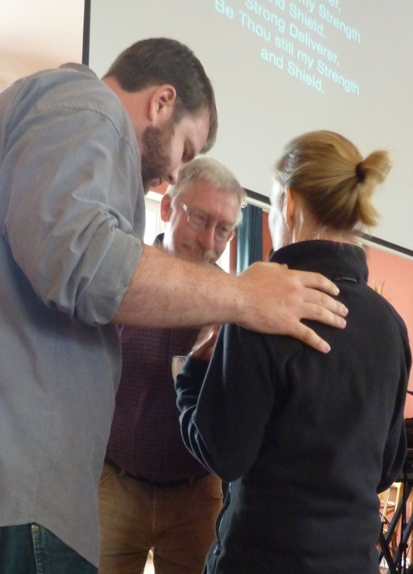

**Where do we serve them?**

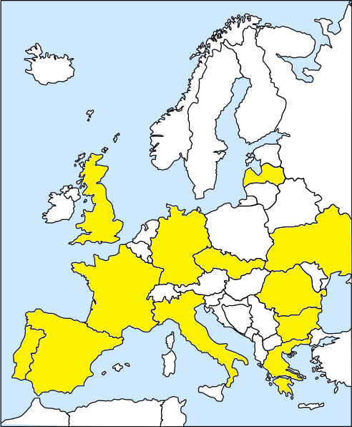

**Slovakia**

**Italy**

**Greece**

**Bulgaria**

**Romania**

**Ukraine**

**Latvia**

**Czech**

**Germany**

**France**

**Spain**

**Portugal**

